TETE 3102 MICROCONTROLLERS AND APPLICATIONS
The ADC Peripheral on STM32
Study notes with worked examples and practice questions
Department of Electrical and Electronics Engineering
Lecturer: Dickson Mugerwa (Ph.D.)
Practical sessions: Mr. Matovu Paul – STM32 Expert
Based on the lecture slides “ADC Analog to Digital Converter”. Target device: STM32F411RE (reference manual RM0383).
How to use these notes
Read one section at a time. Before reading each worked example, cover the solution and try it on paper. When you finish the notes, attempt the practice questions in Part 8 before looking at the answers in the Appendix. Where a question involves the microcontroller, try it on the board in the lab.
Unless stated otherwise, the ADC reference voltage is V_{ref} = 3.3 V.

Contents
- Analog and digital signals
- The light sensor
- The ADC in STM32: resolution and conversion formulas
- Conversion time
- Conversion modes
- Programming the ADC with HAL (polling and interrupts)
- Quick reference
- Practice questions
- Appendix Answers and worked solutions

Learning objectives
After studying these notes you should be able to:
- Explain the difference between analog and digital signals and why a microcontroller needs an ADC;
- Describe how a light sensor produces a voltage and calculate that voltage;
- Use resolution to find the number of levels and step size, and convert between ADC values and voltages;
- Compare the STM32 ADC conversion modes and choose one for an application;
- Calculate the ADC conversion time and choose a sampling time;
- Write HAL code that reads the ADC by polling and by interrupt, and use the value to control LEDs;
- Solve exam-style calculation and code questions on the ADC.

1 Analog and digital signals
Almost everything a microcontroller needs to measure in the real world (light, temperature, sound, pressure, distance) is an analog quantity. The processor inside the microcontroller, however, works only with digital numbers. The analog-to-digital converter (ADC) is the bridge between the two.

1.1 Analog signals
- Continuous: the value changes smoothly over time and can take any value within a range.
- Usually drawn as a sine wave or another smooth curve.
- Examples: the output voltage of a light sensor, of a temperature sensor, or of a microphone.

1.2 Digital signals
- Discrete in both voltage and time: only certain values are allowed, and they change only at certain instants.
- Represented by binary numbers (0s and 1s). This is how data is stored and processed in every digital system.
- Example: the number 2048 held in a variable is 1000 0000 0000 in 12-bit binary.
Feature | Analog signal | Digital signal
Time | Continuous | Discrete (sampled at instants)
Value | Any value in a range | Only a fixed set of levels
Representation | Voltage or current waveform, e.g. a sine wave | Binary numbers (0s and 1s)
Examples | Light level, temperature, sound | ADC output value, logic 0 and 1
Can the CPU use it directly? | No | Yes

1.3 Why a microcontroller needs an ADC
A normal GPIO input can only tell you whether a pin is HIGH or LOW. The output of a light sensor can be anywhere between 0 V and 3.3 V, and the exact value matters because it tells you how bright it is. The ADC measures the voltage and gives the CPU an integer that the program can compare, calculate with, display or send over a serial port.
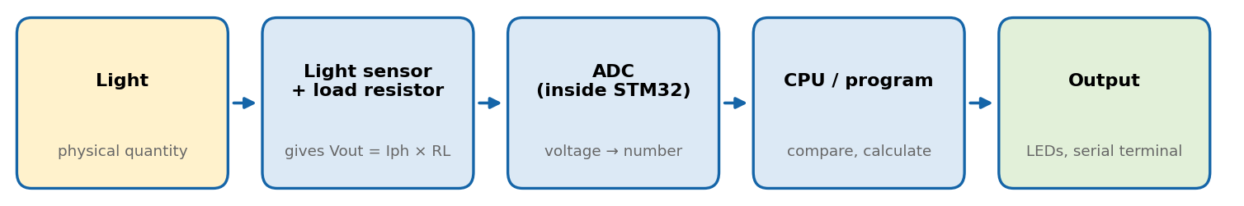
Figure 1. Signal chain in the light-sensor practical: the ADC turns the sensor voltage into a number the program can use.

1.4 Sampling and quantisation
Converting an analog signal into a digital one involves two steps:
- Sampling: measuring the signal at regular instants of time.
- Quantisation: rounding each measured voltage to the nearest of a fixed number of levels. The number of levels depends on the resolution (Section 3).
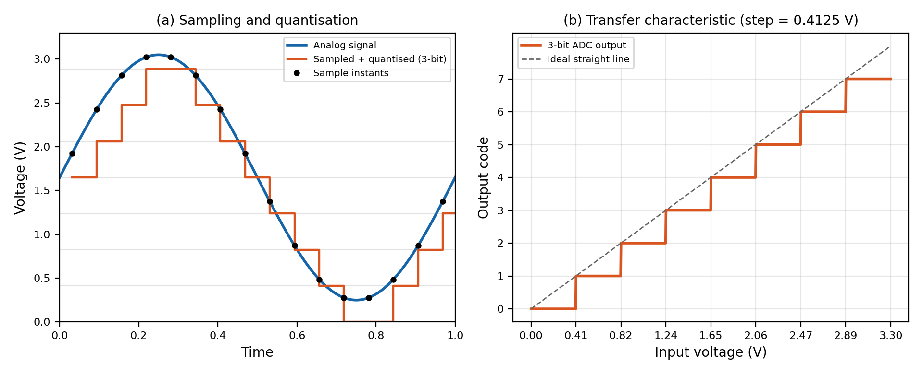
Figure 2. (a) A sine wave sampled and quantised by a 3-bit ADC. (b) The transfer characteristic of a 3-bit ADC with a 3.3 V reference.
Sampling rate (extra background). To capture a signal properly the ADC must sample at more than twice the highest frequency in the signal (the Nyquist criterion). A light level that changes over seconds needs only a few samples per second; an audio signal needs thousands.
Example 1.1 A 3-bit ADC
A 3-bit ADC has V_{ref} = 3.3 V. (a) How many levels does it have? (b) What is the step size? (c) What code does an input of 1.0 V give?
(a) 2³ = 8 levels, so the codes run from 0 to 7.
(b) Step = 3.3 V / 8 = 0.4125 V.
(c) 1.0 / 0.4125 = 2.42, so the code is 2 (binary 010). This code represents every input from 0.825 V to 1.2375 V, so the ADC cannot tell 0.9 V from 1.2 V. More bits give smaller steps and a smaller error.

2 The light sensor

2.1 What it does
A light sensor detects the amount of light energy falling on it and turns it into an electrical signal. The ambient light photo sensor on the SIPI board used in the practical sessions is sensitive to the visible spectrum, that is, the light we can see.

2.2 How it works
The sensor in Figure 3 is a phototransistor. Photons of light striking it make a small current flow, called the photocurrent I_{ph}. The brighter the light, the larger I_{ph}. An ADC measures voltage, not current, so I_{ph} is passed through a load resistor R_{L}, which converts it to a voltage:
V_{out} = I_{ph} × R_{L}
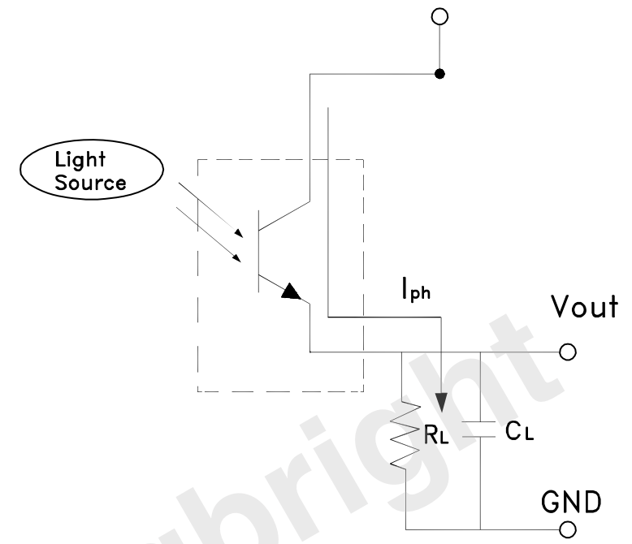
Figure 3. Light sensor circuit. Source: lecture slides (Kingbright ambient light sensor datasheet).
The output voltage is therefore proportional to the light intensity:
more light → larger I_{ph} → larger V_{out} → larger ADC value
The capacitor C_{L} across the output smooths rapid changes; together with R_{L} it acts as a simple low-pass filter.
Keep V_{out} inside the ADC range
The STM32 ADC accepts 0 V to 3.3 V. When you choose R_{L}, make sure that V_{out} = I_{ph,max} × R_{L} never goes above 3.3 V (see Example 2.2).

Example 2.1 From light to ADC value
In moderate light a sensor produces I_{ph} = 150 µA (illustrative value) with R_{L} = 10 kΩ. What ADC value (12-bit, 3.3 V) do you expect?
V_{out} = 150 µA × 10 kΩ = 1.5 V.
ADC value = (1.5 / 3.3) × 4095 ≈ 1861.

Example 2.2 Choosing the load resistor
The brightest light you expect gives I_{ph,max} = 400 µA. Choose R_{L} so that V_{out} stays within 3.3 V.
R_{L} ≤ 3.3 V / 400 µA = 8.25 kΩ.
The nearest standard value below this is 8.2 kΩ, which gives V_{out,max} = 400 µA × 8.2 kΩ = 3.28 V. This is just inside the limit, so in practice you might choose a smaller value such as 6.8 kΩ (2.72 V) for some margin.

2.3 Real-world applications
Application | How the light sensor is used
Street lighting systems | Lamps switch on automatically when the ambient light falls below a threshold (dusk) and off again at dawn.
Solar tracking systems | Sensors on different sides of a panel compare the light they receive so the panel can turn towards the brightest direction.
Mobile phones | Screen brightness is adjusted to the surroundings.
Notebooks (laptops) | Screen and keyboard backlight adjust to room lighting, saving battery.
Video cameras | The scene brightness is measured to help set the exposure.

3 The ADC in STM32: resolution and conversion formulas

3.1 Overview
The analog-to-digital converters inside STM32 microcontrollers allow the microcontroller to accept an analog value, such as a sensor output, and convert it into the digital domain. In this course we use the STM32F411RE; the details in these notes come from its reference manual (RM0383). The sensor is connected to an ADC channel (a pin configured in analog mode).
Never exceed the input range
The ADC input range is 0 V to 3.3 V. Do not connect a 5 V signal directly to an ADC pin: the reading will saturate at the maximum value and the pin can be damaged. Use a voltage divider to scale larger voltages down.

3.2 Resolution
The resolution is the number of bits in the result. An n-bit ADC has 2^{n} levels, and its output runs from 0 to 2^{n} − 1. The STM32 ADC lets you choose the resolution. The 12-bit setting maps voltages between 0 and 3.3 V into integers between 0 and 4095.
Resolution | Levels (2^{n}) | Output range | Step size at 3.3 V (V_{ref} / 2^{n})
12-bit | 4096 | 0 – 4095 | 0.806 mV
10-bit | 1024 | 0 – 1023 | 3.22 mV
8-bit | 256 | 0 – 255 | 12.9 mV
6-bit | 64 | 0 – 63 | 51.6 mV

A higher resolution means finer measurements, but the conversion takes more ADC clock cycles (Section 4). The smallest voltage change that one step represents is called the least significant bit (LSB).

3.3 Conversion formulas
Step size (1 LSB) = V_{ref} / 2^{n}
ADC value N = (V_{in} / V_{ref}) × (2^{n} − 1)
V_{in} = N × V_{ref} / (2^{n} − 1)
A small detail: 4095 or 4096?
The lecture maps 0 – 3.3 V onto 0 – 4095, so these notes divide by 2^{n} − 1 when converting between codes and voltages. Some books use 2^{n}. The difference is about 0.02 % for a 12-bit ADC and does not matter in practice. Use the form your lecturer specifies in an examination.

Quantisation error. Because every input in a step gives the same code, the ADC has a maximum error of ± ½ LSB. For a 12-bit ADC at 3.3 V that is about ± 0.4 mV.
Example 3.1 ADC value to voltage
A 12-bit ADC (V_{ref} = 3.3 V) returns 2048. What is the input voltage?
V_{in} = 2048 × 3.3 / 4095 = 1.650 V, which is about half of the range, as expected.

Example 3.2 Voltage to ADC value
What 12-bit ADC values correspond to (a) 2.5 V and (b) 1.0 V?
(a) N = (2.5 / 3.3) × 4095 = 3102.3, so N ≈ 3102.
(b) N = (1.0 / 3.3) × 4095 = 1240.9, so N ≈ 1241. This is the ADC threshold you would use in a program to test for “input below 1.0 V”.

Example 3.3 Changing the resolution
What 8-bit value corresponds to 2.5 V? Compare it with the 12-bit value from Example 3.2.
N = (2.5 / 3.3) × 255 = 193.2, so N ≈ 193. Going from 12 bits to 8 bits removes 4 bits, so the value is about 16 times smaller: 3102 / 16 ≈ 194. The 8-bit reading is 16 times coarser (12.9 mV per step instead of 0.806 mV).

Reading the light sensor in practice
The ADC value is roughly proportional to the light level: near 0 in darkness and higher in bright light. The exact numbers depend on the sensor, R_{L} and the room, so find your thresholds by experiment: print the values in a dark room, in normal room light and with a torch shining on the sensor.

4 Conversion time
A conversion is not instant. The time it takes depends on the resolution, the ADC clock and the sampling time. Table 1 (from the reference manual, page 212) gives the number of ADC clock cycles needed for the conversion itself.
Table 1. ADC conversion cycles (lecture slide 9, RM0383).
Resolution | Normal conversion mode (cycles) | Fast conversion mode (cycles)
12-bit | 12 | 15
10-bit | 10 | 13
8-bit | 8 | 11
6-bit | 6 | 9

Terms you need
- Sampling time: the number of ADC clock cycles the input stays connected to the ADC's internal sampling capacitor so that it can charge to the input voltage. A sensor with a high output resistance needs a longer sampling time. You set this in the ADC configuration.
- Cycles: the conversion cycles from Table 1 (for example 15 for 12-bit in fast mode).
- ADC clock: derived from the APB2 bus clock divided by a prescaler (2, 4, 6 or 8 on the STM32F4). The datasheet limits the maximum ADC clock (36 MHz for this family at full supply voltage).
ADC clock = f_{APB2} / prescaler
T_{conv} = (sampling time + cycles) / ADC clock
sampling time = (T_{conv} × ADC clock) − cycles
The second formula is what you use to find the sampling time when you are given a target conversion time.
Example 4.1 Choosing the sampling time (from the lecture)
STM32F411RE, 12-bit resolution in fast mode (15 cycles), APB2 = 84 MHz, ADC prescaler = 8. The conversion time should be at least 10 µs; aim for 12 µs. Find the sampling time.
Step 1. ADC clock = 84 MHz / 8 = 10.5 MHz.
Step 2. Total cycles in 12 µs = 12 µs × 10.5 MHz = 126 cycles.
Step 3. Sampling time = 126 − 15 = 111 cycles.
Step 4. The hardware offers only certain sampling times (on STM32F4: 3, 15, 28, 56, 84, 112, 144 or 480 cycles; check the drop-down in CubeMX). Choose the nearest, 112 cycles. Then T_{conv} = (112 + 15) / 10.5 MHz = 12.1 µs, which meets the requirement.

Example 4.2 The fastest conversion
Using the same 84 MHz APB2 clock with prescaler 4, 12-bit fast mode and the shortest sampling time (3 cycles), find T_{conv} and the maximum sampling rate.
ADC clock = 84 / 4 = 21 MHz. Total cycles = 3 + 15 = 18.
T_{conv} = 18 / 21 MHz = 0.857 µs, so the maximum sampling rate is 1 / 0.857 µs ≈ 1.17 million samples per second.

Do you need to be fast?
A light level changes slowly, so a conversion time of 12 µs is more than fast enough. A longer sampling time also gives a more accurate reading when the sensor has a high output resistance. Choose the speed your application needs, not the maximum.

5 Conversion modes
The ADC can be set up in several conversion modes. Figure 4 shows them as flow charts, from left to right: single, single continuous, scan (multi-channel), scan continuous (multi-channel repeat) and discontinuous.
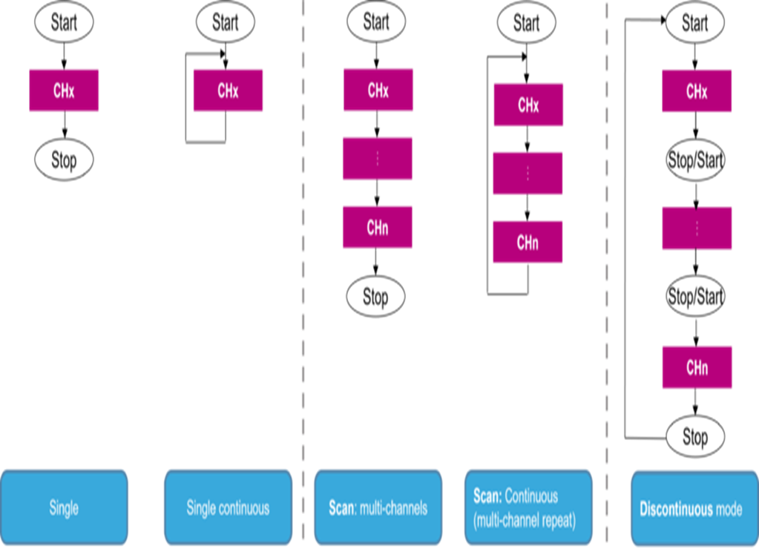
Figure 4. STM32 ADC conversion modes (lecture slide 8). CHx … CHn are the ADC channels being converted.
Mode | What the ADC does | Restarts by itself? | Typical use
Single conversion | Does one conversion of one channel, then stops. | No. Software must start it each time. | Occasional readings, e.g. a light level once a second.
Continuous conversion | Starts a new conversion as soon as it finishes one. | Yes | Always having a fresh value; used with interrupts or DMA.
Scan mode | Converts a group of channels (CHx to CHn) one after another. | Stops after the group, or repeats if continuous mode is also on. | Reading several sensors together.
Discontinuous mode | Converts only a single channel at each trigger signal, from the list of programmed channels. | No. Each trigger converts the next channel. | Timer-triggered or controlled-timing measurements.

Choosing a mode
- One sensor, occasional reading: single channel, single conversion (Task 1 in Section 6).
- One sensor, latest value always wanted and the CPU should stay free: single channel, continuous conversion with interrupts (Task 2 in Section 6).
- Several sensors: scan mode (usually with DMA, which copies the results to memory without the CPU).
- Each channel must be measured only on a trigger: discontinuous mode.

6 Programming the ADC with HAL
This section follows the two practical tasks in the lecture. Both read a light sensor on a single channel. Task 1 uses a single conversion with polling; Task 2 uses continuous conversion with interrupts.

6.1 Setting up the ADC in STM32CubeIDE
- Create a project for your board and open the .ioc file (the CubeMX configuration screen).
- Enable ADC1 and tick the input channel that the light sensor is connected to (your lab sheet gives the pin). The pin is set to analog mode automatically.
- In the ADC parameters set the Resolution (12 bits), and set Continuous Conversion Mode to Disabled for Task 1 or Enabled for Task 2. Leave Scan Conversion Mode disabled for a single channel.
- Set the ADC clock prescaler and the sampling time using the calculation in Section 4.
- For Task 2, open NVIC Settings and enable the ADC1 global interrupt. Without this, the callback is never called.
- Enable a USART (for example USART2, which is often the ST-Link virtual COM port on Nucleo boards) for sending values to the terminal. Set two GPIO pins as outputs for the blue and red LEDs and give them user labels such as LED_BLUE and LED_RED.
- Generate the code. Write your own code only between the USER CODE BEGIN and USER CODE END comments, otherwise regenerating will erase it.

6.2 The HAL functions you need
Function | What it does
HAL_ADC_Start(&hadc1) | Starts the ADC (polling method).
HAL_ADC_PollForConversion(&hadc1, 100) | Waits until the conversion is finished or until the timeout (here 100 ms) expires. Returns HAL_OK on success or HAL_TIMEOUT.
HAL_ADC_GetValue(&hadc1) | Returns the result of the last conversion (0 – 4095 in 12-bit mode).
HAL_ADC_Stop(&hadc1) | Stops the ADC.
HAL_ADC_Start_IT(&hadc1) | Starts the ADC with interrupts enabled.
HAL_ADC_ConvCpltCallback(hadc) | Callback that HAL calls when a conversion is complete. You write the body.

6.3 Task 1: single channel, single conversion, polling
Task 1
Read the ADC values from the light sensor and display them on a serial terminal, for example Docklight.

The core code from the lecture is:
// start the adc
HAL_ADC_Start(&hadc1);
// poll for conversion
HAL_ADC_PollForConversion(&hadc1, 100);
// get the adc value
LightSensor_val = HAL_ADC_GetValue(&hadc1);
// stop adc
HAL_ADC_Stop(&hadc1);
Each call has a job. HAL_ADC_Start begins one conversion. HAL_ADC_PollForConversion blocks (the CPU just waits) until the ADC signals the end of the conversion. HAL_ADC_GetValue reads the result. HAL_ADC_Stop stops the ADC so the loop can start it again. Because the CPU is stuck waiting, this is called blocking mode. It is simple, but it wastes time in larger programs.
A complete version that also checks for a timeout, converts to millivolts and prints the result:
/* USER CODE BEGIN Includes */
#include <stdio.h>
/* USER CODE END Includes */

/* USER CODE BEGIN PV */
uint32_t LightSensor_val = 0;
char msg[48];
/* USER CODE END PV */

/* ---- inside the while(1) loop of main() ---- */
HAL_ADC_Start(&hadc1);
if (HAL_ADC_PollForConversion(&hadc1, 100) == HAL_OK)
{
LightSensor_val = HAL_ADC_GetValue(&hadc1);
}
HAL_ADC_Stop(&hadc1);

uint32_t mV = (LightSensor_val * 3300UL) / 4095UL;
int len = sprintf(msg, "ADC=%lu V=%lu mV\r\n", LightSensor_val, mV);
HAL_UART_Transmit(&huart2, (uint8_t *)msg, len, 100);

HAL_Delay(500); /* one reading every half second */
Viewing the values on the terminal
Connect the board, open Docklight (or any serial terminal), select the board's COM port and set the same baud rate, data bits, parity and stop bits as your USART configuration (for example 115200, 8, N, 1). Cover the sensor with your hand and the values should fall; shine a torch on it and they should rise. The UART handle name (huart2) depends on your CubeMX settings.

6.4 Task 2: single channel, continuous conversion, interrupts
Task 2
Read the ADC values from the light sensor and display them on a serial terminal.
Low light intensity: turn on the blue LED.
High light intensity: turn on the red LED.

The interrupt code from the lecture is:
/* INTERRUPT callback function */
void HAL_ADC_ConvCpltCallback(ADC_HandleTypeDef* hadc)
{
//get the adc value
LightSensor_val = HAL_ADC_GetValue(&hadc1);
}

//Start ADC with interrupt
HAL_ADC_Start_IT(&hadc1);
How it works. You call HAL_ADC_Start_IT once, before the main loop. In continuous mode the ADC then keeps converting by itself. Each time a conversion finishes, the ADC raises an interrupt, HAL handles it and calls HAL_ADC_ConvCpltCallback, and your callback stores the new value. The main loop is free to do other work and simply uses the latest value.
A complete version with the LED logic:
#define LIGHT_THRESHOLD 2000 /* choose after testing your sensor */

volatile uint32_t LightSensor_val = 0; /* changed inside an interrupt */

void HAL_ADC_ConvCpltCallback(ADC_HandleTypeDef *hadc)
{
LightSensor_val = HAL_ADC_GetValue(&hadc1);
}

/* in main(), before the while(1) loop */
HAL_ADC_Start_IT(&hadc1);

/* inside the while(1) loop */
if (LightSensor_val < LIGHT_THRESHOLD) /* low light: blue LED */
{
HAL_GPIO_WritePin(LED_BLUE_GPIO_Port, LED_BLUE_Pin, GPIO_PIN_SET);
HAL_GPIO_WritePin(LED_RED_GPIO_Port, LED_RED_Pin, GPIO_PIN_RESET);
}
else /* high light: red LED */
{
HAL_GPIO_WritePin(LED_BLUE_GPIO_Port, LED_BLUE_Pin, GPIO_PIN_RESET);
HAL_GPIO_WritePin(LED_RED_GPIO_Port, LED_RED_Pin, GPIO_PIN_SET);
}
/* then send LightSensor_val to the terminal every 500 ms, as in Task 1 */
Rules for interrupt callbacks
Keep the callback short. Store the value and return. Do not call HAL_Delay or sprintf inside it. Do the slow work in the main loop.
Declare shared variables volatile. A variable changed in an interrupt and read in the main loop must be volatile, otherwise the compiler may keep an old copy in a register and your loop will never see the new value.
LED polarity depends on the wiring. On some boards GPIO_PIN_SET turns an LED off. Test and swap if needed.

Polling compared with interrupts
 | Polling (blocking) | Interrupt
CPU while waiting | Busy, doing nothing else | Free to do other work
Code | Simple | Needs a callback and the NVIC interrupt enabled
Response | When your code next checks | As soon as the conversion finishes
Usual conversion mode | Single conversion | Continuous conversion
Best for | Simple programs and learning | Responsive programs doing several jobs

A third method, DMA, copies results into memory with no CPU involvement at all. It is the usual choice for scan mode with several channels, and you will meet it later.

6.5 Getting better readings
- Average several samples to reduce noise (see Question D2).
- Use two thresholds (hysteresis) so an LED or lamp does not flicker when the light level hovers near a single threshold (see Question D1).
- Increase the sampling time if the sensor has a high output resistance and the readings look too low or unstable.
- Do not leave the input floating. An unconnected ADC pin gives random values.

6.6 Troubleshooting
Symptom | Likely cause | Fix
Reading is always 0 | Wrong channel or pin, sensor not connected, or the ADC was never started | Check the channel and wiring; call HAL_ADC_Start
Reading is always 4095 | Input at or above 3.3 V; R_{L} too large, so the input saturates | Measure V_{out}; reduce R_{L} (Example 2.2)
Values jump around | Noise, floating input, sampling time too short | Average samples; lengthen sampling time
PollForConversion returns HAL_TIMEOUT | ADC not started, or timeout shorter than the conversion time | Call HAL_ADC_Start first; use a timeout such as 100 ms
Callback never runs | HAL_ADC_Start_IT not called, or ADC interrupt not enabled in NVIC | Enable the ADC1 global interrupt; call HAL_ADC_Start_IT
Value never changes in the main loop | Shared variable is not volatile | Declare it volatile
Nothing appears on the terminal | Wrong COM port or baud rate mismatch | Match the USART settings; check the port

7 Quick reference
Quantity | Formula
Number of levels | 2^{n}
Highest output code | 2^{n} − 1 (4095 for 12-bit)
Step size (1 LSB) | V_{ref} / 2^{n} (0.806 mV for 12-bit at 3.3 V)
ADC value from voltage | N = (V_{in} / V_{ref}) × (2^{n} − 1)
Voltage from ADC value | V_{in} = N × V_{ref} / (2^{n} − 1)
Maximum quantisation error | ± ½ LSB
Light sensor output voltage | V_{out} = I_{ph} × R_{L}
ADC clock | f_{APB2} / prescaler
Conversion time | T_{conv} = (sampling time + cycles) / ADC clock
Sampling time for a target T_{conv} | (T_{conv} × ADC clock) − cycles
Millivolts in integer C code | mV = (val * 3300UL) / 4095UL;

Key terms
Term | Meaning
ADC | Analog-to-digital converter: turns a voltage into an integer.
Channel | One analog input of the ADC (a pin in analog mode).
Resolution | Number of bits in the ADC result (12, 10, 8 or 6 on the STM32F4).
LSB | The voltage represented by one step of the ADC.
V_{ref} | Reference voltage: the input that gives the maximum code (3.3 V here).
Sampling time | Cycles during which the ADC input is connected to the sampling capacitor.
Prescaler | Divider that produces the ADC clock from the APB2 bus clock.
Polling | Repeatedly checking or waiting for a flag in software.
Interrupt / callback | Hardware event that makes the CPU run a function as soon as it occurs.

8 Practice questions

Part A Reading and writing code
C1. This polling loop reads the light sensor but never gives a sensible value. Find the errors.
uint16_t val;
while (1)
{
HAL_ADC_PollForConversion(&hadc1, 100);
val = HAL_ADC_GetValue(&hadc1);
HAL_Delay(100);
}
C2. Write the polling code that reads the ADC into val, then turns on the red LED if val is greater than 3000 and the blue LED otherwise. Use LED_RED_* and LED_BLUE_* as the pin names.
C3. Write one line of C that converts val (0 – 4095) into millivolts using integer arithmetic. What does it give for val = 2048?
C4. Fill in the blanks (a), (b) and (c) in this interrupt-driven program.
volatile uint32_t light;

void ____(a)____(ADC_HandleTypeDef *hadc)
{
light = ____(b)____(&hadc1);
}

int main(void)
{
/* initialisation code omitted */
____(c)____(&hadc1);
while (1) { /* use light */ }
}
C5. Explain why light in C4 is declared volatile.
C6. A student runs the program in C4 but forgot to enable the ADC1 global interrupt in the NVIC. Describe what happens.

Part D Design and lab challenges
D1. Street lamp. A lamp should switch on when it gets dark and off when it gets light, without flickering around the switching point. Choose two 12-bit thresholds and write the control code. Explain why two thresholds are better than one.
D2. Noise reduction. Write code that takes 16 polling readings of the ADC and calculates their average.
D3. Nicer output. Print the sensor voltage on the terminal in the form 1.650 V without using floating-point printf.

